In further analyzing a given problem, formulating a mathematical model is very integral and crucial. The dynamic analysis of a given system can be accomplished by multiple techniques, but we will be specifically hovering through the *Natural Frequencies and modes* and some elements of the *transient analysis*.

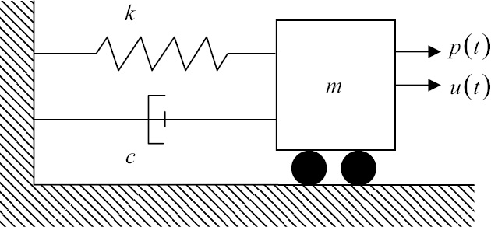We’ll start to deduce the governing equations involved by studying single degree of freedom models, these models are often coupled with two degree of freedom models to generate the governing equations for Automotive Structures and for their Side-Frame Geometry dynamics.

Figure: Single Degree of Freedom (Spring – Mass – Dashpot) Model

$$u\left(t\right):Displacement$$

$$f\left(t\right):Excitation Force (External Force Applied)$$

As per the Newton’s Law of Motion:

$$mass*Acceleration=Force$$

Or

$$m*\frac{d^{2}u}{dt^{2}}=f\left(t\right)-k*u-\frac{du}{dt}$$

*Now, as we know*

$$Acceleration :\frac{d^{2}u}{dt^{2}}$$

$$Velocity: \frac{du}{dt}$$

Now, we could have different cases of vibrations, Forced Vibrations and Free Vibration. In a Free Vibration model representation studied in Mechanical Vibrations has been used to work through the formulation of the mathematical model.

Assumptions:

* No inherent damping present across the system i.e. c=0

So, it can be written as -

$m*\frac{d^{2}u}{dt^{2}}= -k*u$*Eq 1*

Wherein the displacement, u can also be represented as for the above system

$u\left(t\right)=A*\sin\left(ω*t\right)$*Eq 2*

*Where,*

$ω:Angular Frequency$

* *A: Amplitude of Oscillations*

*Substituting the value of u from Equation 2 into Equation 1, We get –*

$-m*A*ω^{2}\sin\left(ω*t\right)+k*A*\sin\left(ω*t\right)$*= 0*

$$Taking \left(-ω^{2}*m+k\right) common from the above equation, We get-$$

$$\left(-ω^{2}*m+k\right)U=0$$

$$ω=\sqrt{\frac{k}{m}}$$

*Therefore, the above equation helps us to deduce the fundamental frequencies for a given system whose system stiffness and mass is known.*

*Frequency, thus, obtained from the above formulation will be Undamped Natural Frequency*

*(Cyclic Frequency)*

$f= \frac{ω}{2π}$

*Now, as for the free vibrational model, c is zero. If damping coefficient c is not zero and less than critical damping coefficient Cc*

*0 $0 <C<C_{c}$*

*Where, $damping ratio: \frac{Damping Coefficcent}{Critical Damping Coefficcent}$*

$$Critical Damping\left(C_{C}\right):2*\sqrt{k*m}=2*ω*m$$

*In most of the Engineering structures and its subcomponents is Damping Ratio is more than 0 and less than 0.15, which holds correct for our cantilever beam application for the given problem.*

*In continuum structures, equations are initially defined for infinitesimal small volume and the results are integrated over along the given domain*

*Now, Talking through the aspects of linear elasticity*

*Consider, the situation, where stress in three dimensions need to calculate. In a 3D Region Ω, with a linear elastic solid.*

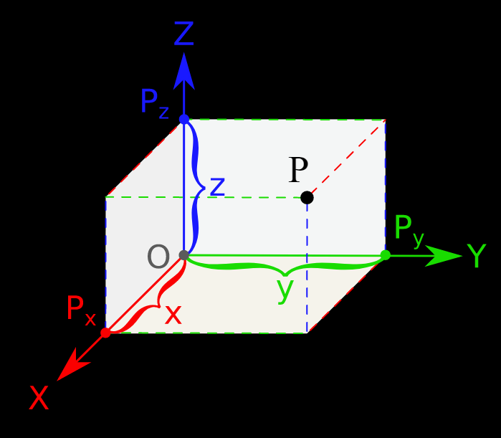

Ω

P (u, v, w)

The origin O (x, y, z), the displacement at point P with respect to origin, as per the right handed convention system has components (u,v,w) measured with respect to the global reference axis as defined in the above picture.

The entire domain boundary Ω is denoted by ℾ. ℾ is further categorized into two parts:

* ℾu: Domain where displacements are specified
* ℾt: Domain where surface traction is specified

Now, take a normal vector **n** normal to the boundary normal to Ω and has components (nx , ny, nz )with respect to the global system.

$$ℾ= ℾ_{u} U ℾ_{t}$$

Now, with the above system definition, we could define our set of differential equations of Equilibrium and Motion respectively for our given application using the principles of conservation of energy along the infinitesimal small volume of element. Where the force along its different faces is calculated.

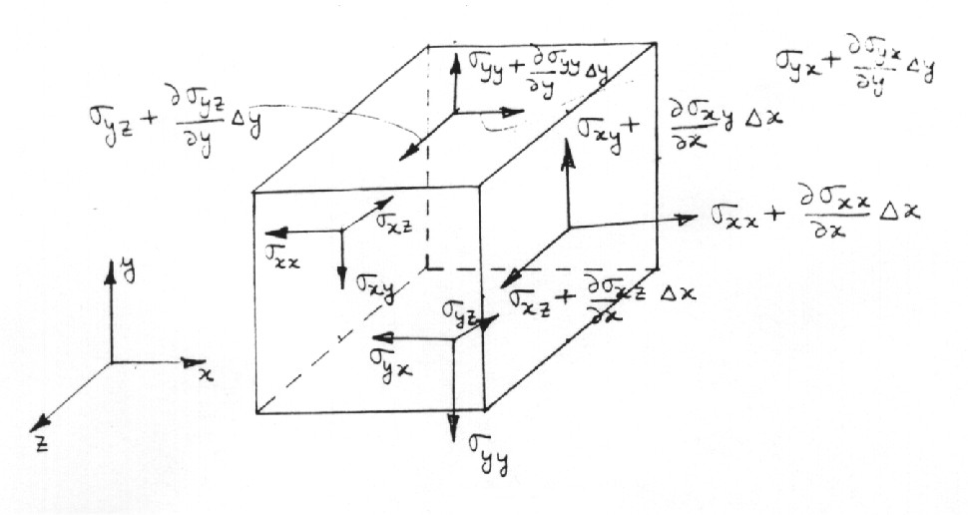

Figure: Force Balance along the x, y and z direction (Shear is neglected at this point)

Figure: Force Balance on the infinitesimal element of domain Ω

Convention Utilized for Force Balance:

Force coming into the system are taken as positive and force leaving the system are negative.

Hence, we obtain the resultant differential equations of Equilibrium

**Differential Equations of Equilibrium**

In one direction, as follows in x direction -

$$\frac{∂σ_{xx}}{∂x}+ \frac{∂σ_{yx}}{∂y}+ \frac{∂σ_{zx}}{∂z}+b_{x}=0$$

Similarly, for other directions (y and z respectively) -

$$\frac{∂σ_{xy}}{∂x}+ \frac{∂σ_{yy}}{∂y}+ \frac{∂σ_{zy}}{∂z}+b_{y}=0$$

$$\frac{∂σ_{xz}}{∂x}+ \frac{∂σ_{yz}}{∂y}+ \frac{∂σ_{zz}}{∂z}+b_{z}=0$$

Where,

**b =** (bx, by, bz) are the respective body forces applied per unit volume.

Together, the above three equations form the differential equations of Equilibrium.

**Differential Equations of Motion -**

Furthermore, discussing over the aspects of Differential Equations of Motion, for conditions, wherein the system is not in static equilibrium. The net force applied across the system results in acceleration in the direction of net resultant force. The differential equations of motion are –

$$\frac{∂σ_{xx}}{∂x}+ \frac{∂σ_{yx}}{∂y}+ \frac{∂σ_{zx}}{∂z}+b_{x}=ρ\frac{∂^{2}u}{∂t^{2}}$$

$$\frac{∂σ_{xy}}{∂x}+ \frac{∂σ_{yy}}{∂y}+ \frac{∂σ_{zy}}{∂z}+b_{y}=ρ\frac{∂^{2}v}{∂t^{2}}$$

$$\frac{∂σ_{xz}}{∂x}+ \frac{∂σ_{yz}}{∂y}+ \frac{∂σ_{zz}}{∂z}+b_{z}=ρ\frac{∂^{2}w}{∂t^{2}}$$

In this condition, equation of equilibrium are equated against the net unit acceleration in that given direction. Where, (u,v,w) are the specified displacement coordinates as specified along the x,y and z direction respectively in the earlier sections of the discussion.